Shital Digambar Bhadre
Assignment 4&5

Q1.
Your current directory is:
/home/student/Documents/Linux
Navigate to the Downloads directory using only a relative path.
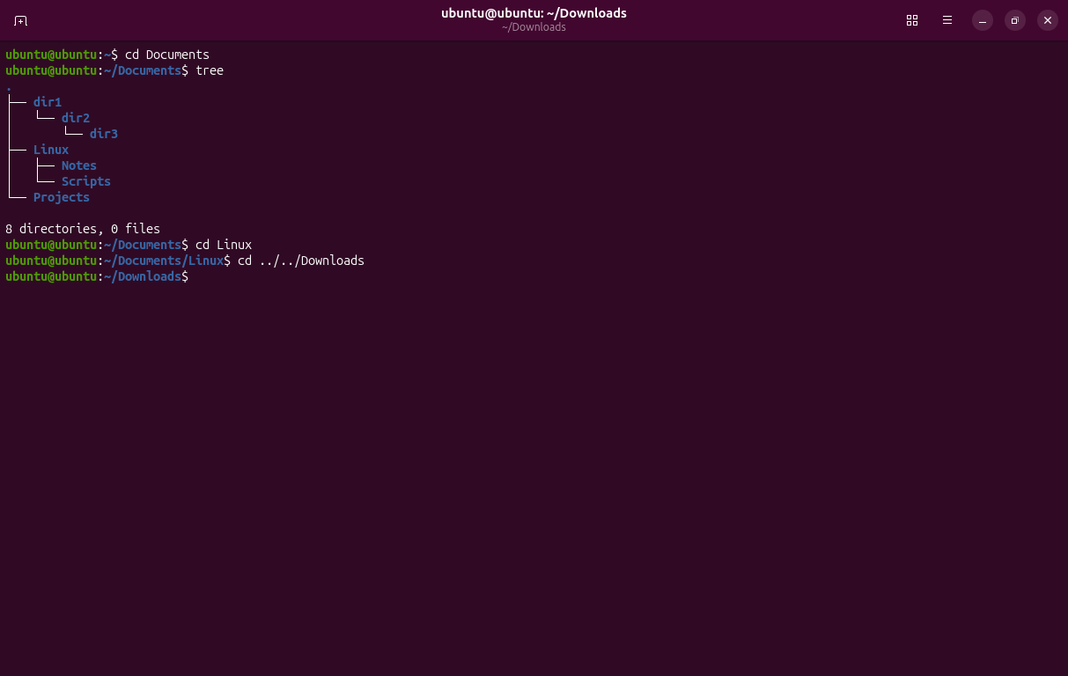

Q2.
Without changing your current directory, display the contents of:
/var/log
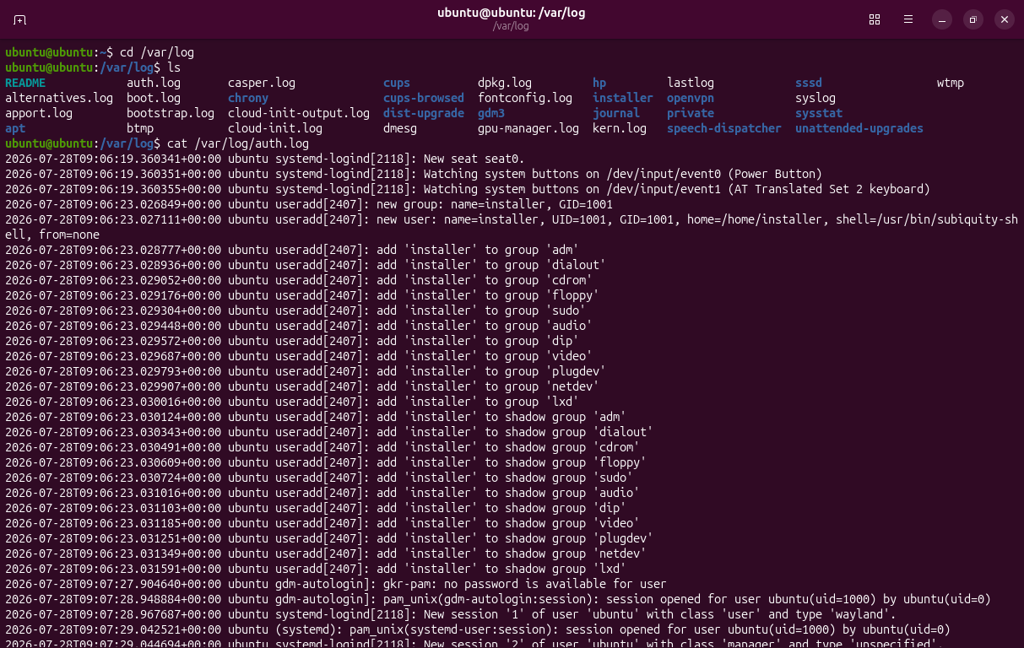
Q3.
You are in:
/home/student/Documents/Projects
Go to your home directory without typing its full path.
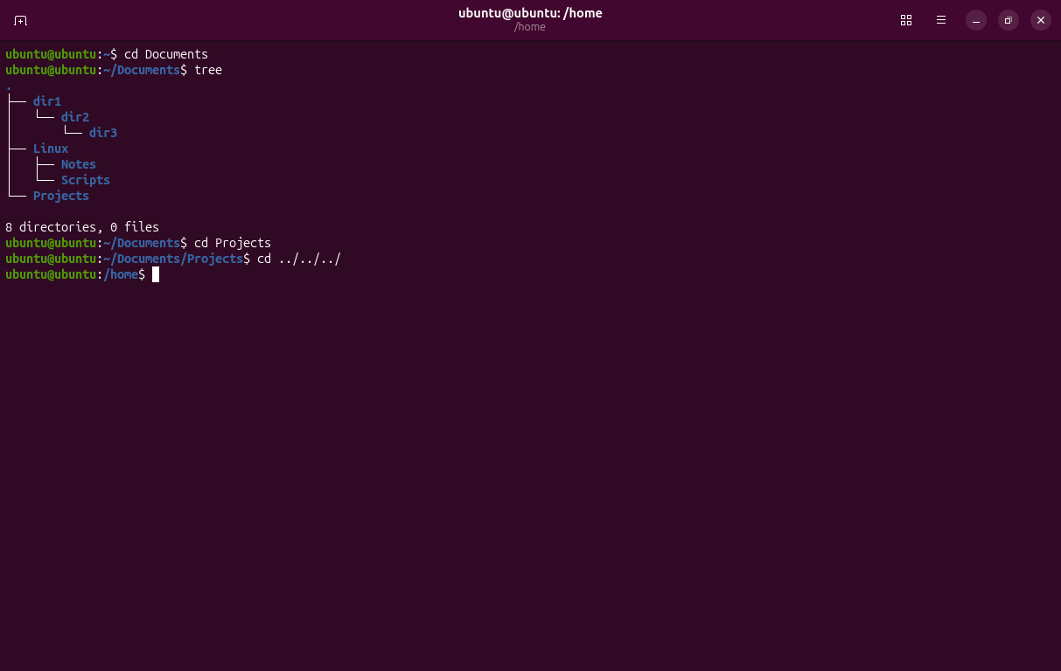
Q4.
You are inside:
/home/student/Documents/Linux/Scripts
Navigate to:
/home/student/Documents
using only a relative path.
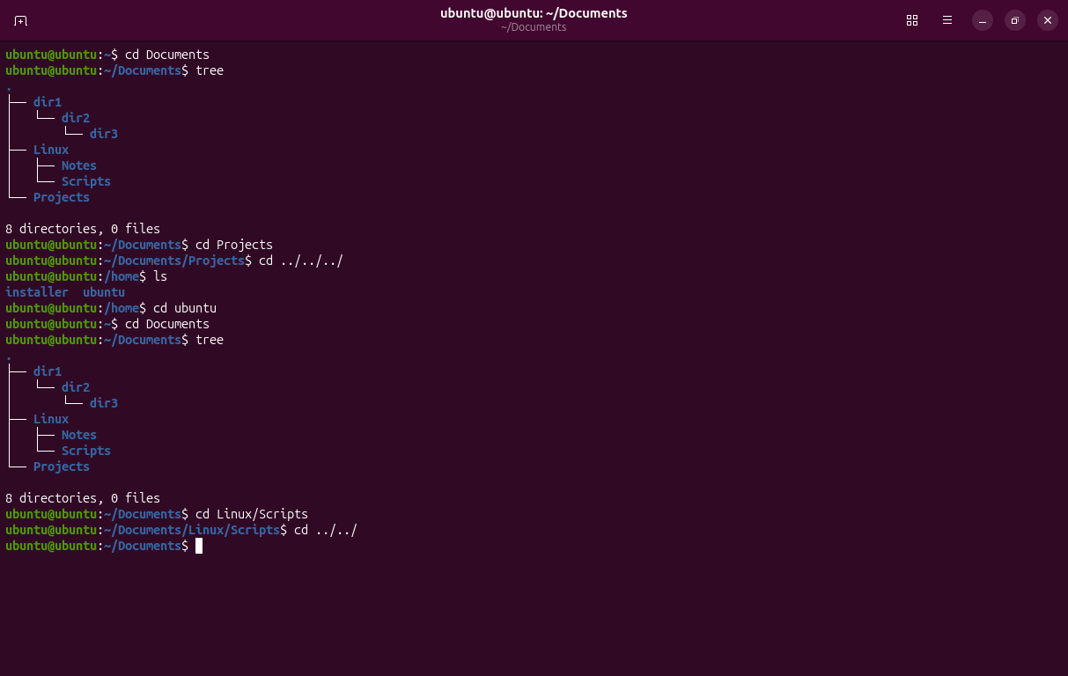
Q5.
Which command will display your current location after changing directories?
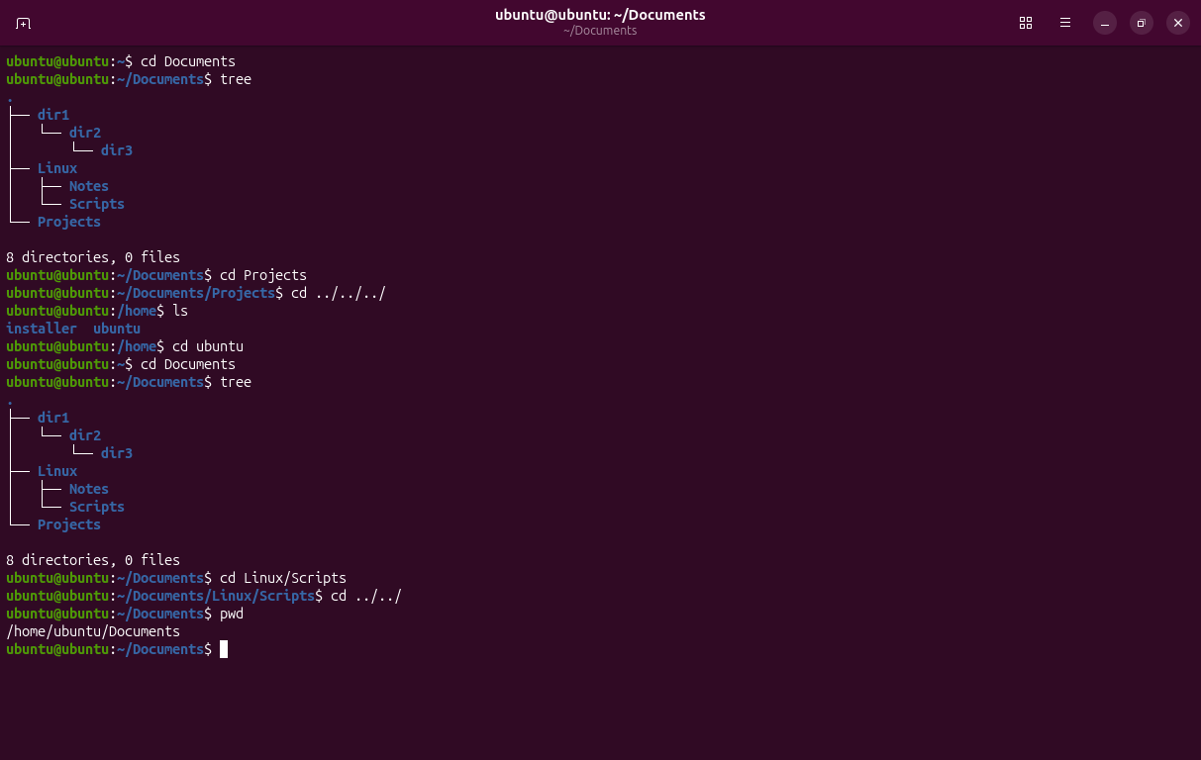
Q6.
Display all files, including hidden files, in long listing format.
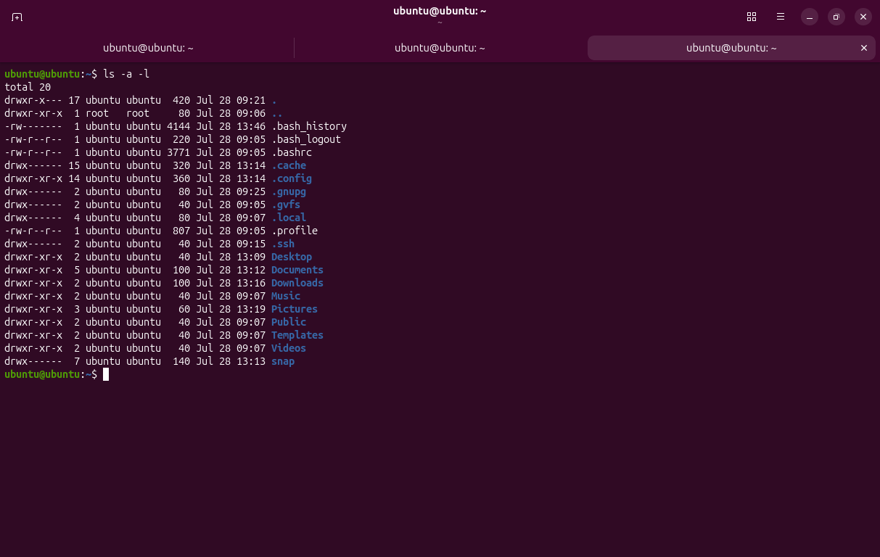
Q7.
List only the contents of the /etc directory without entering it.
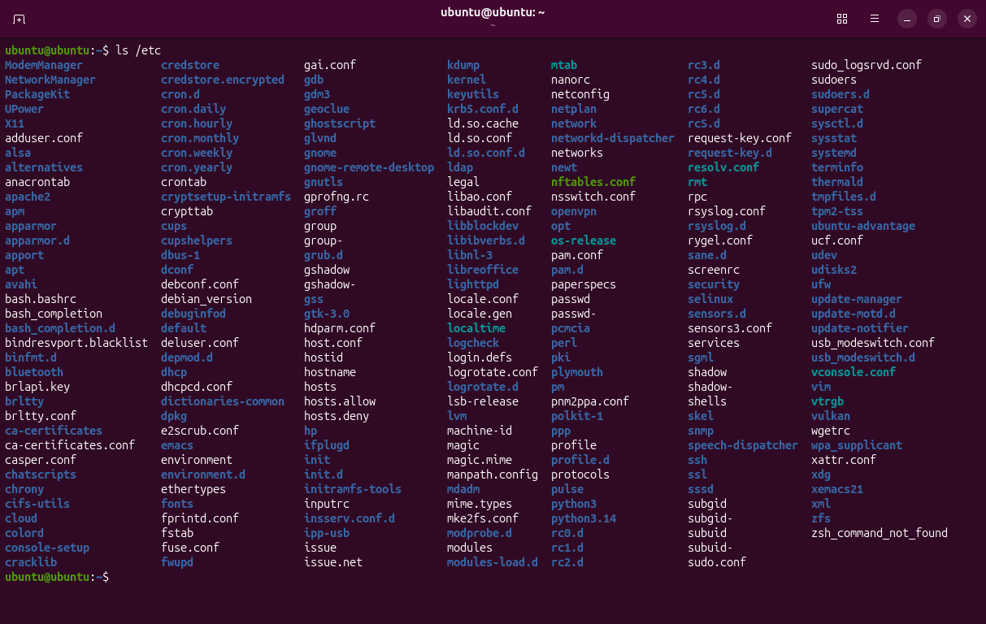
Q8.
Display files sorted by newest first.
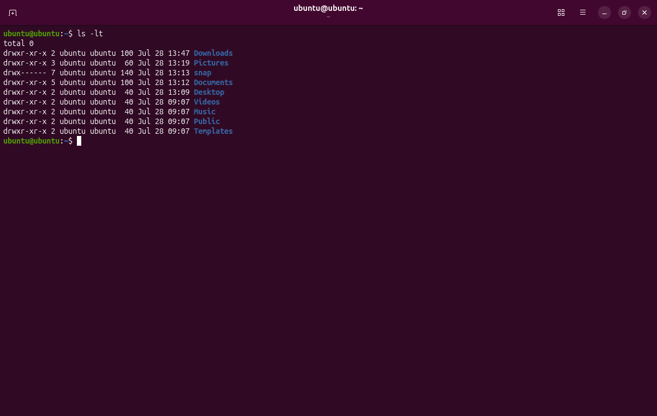
Q9.
Which command shows human-readable file sizes?
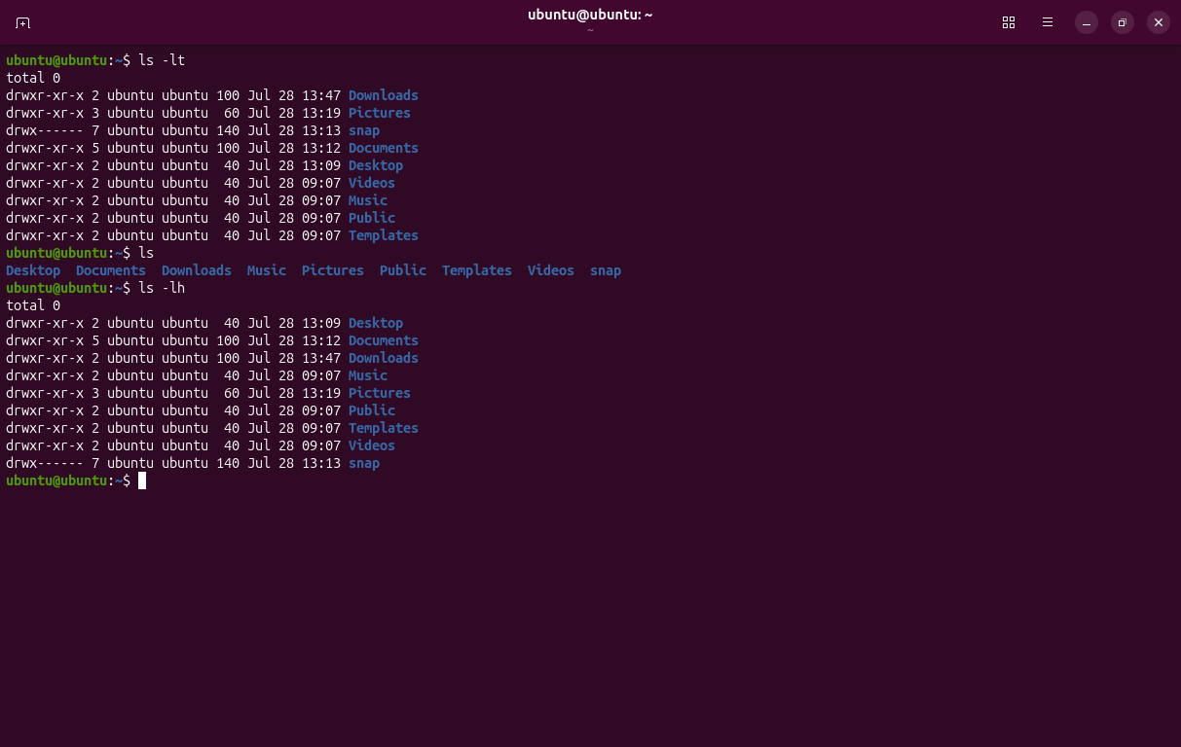
Q10.
You are inside /home/student.
Display the contents of Documents/Linux using a relative path.
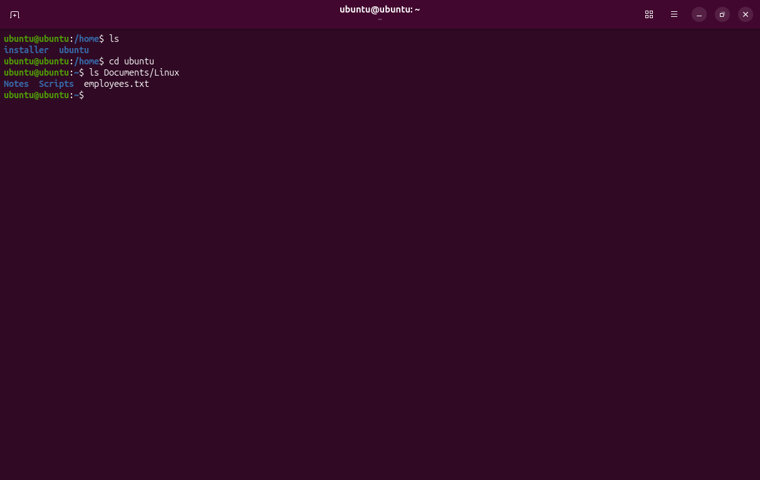
Q11.
Display the contents of employees.txt located in your current directory.
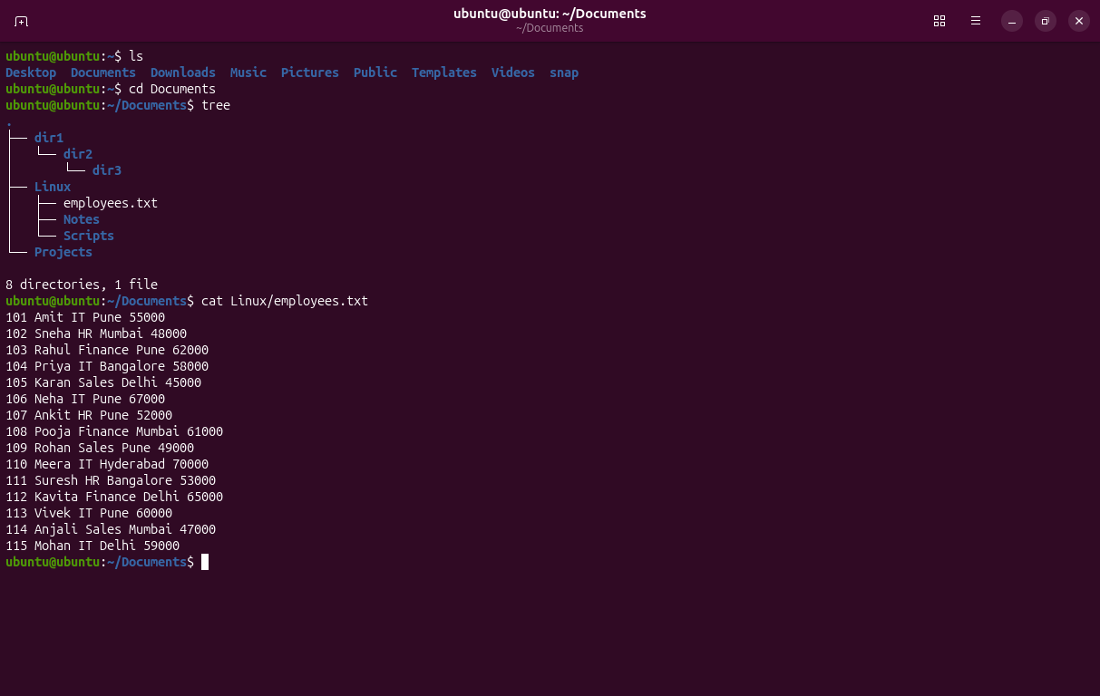
Q12.
Without changing directories, display:
/home/student/Documents/info.txt
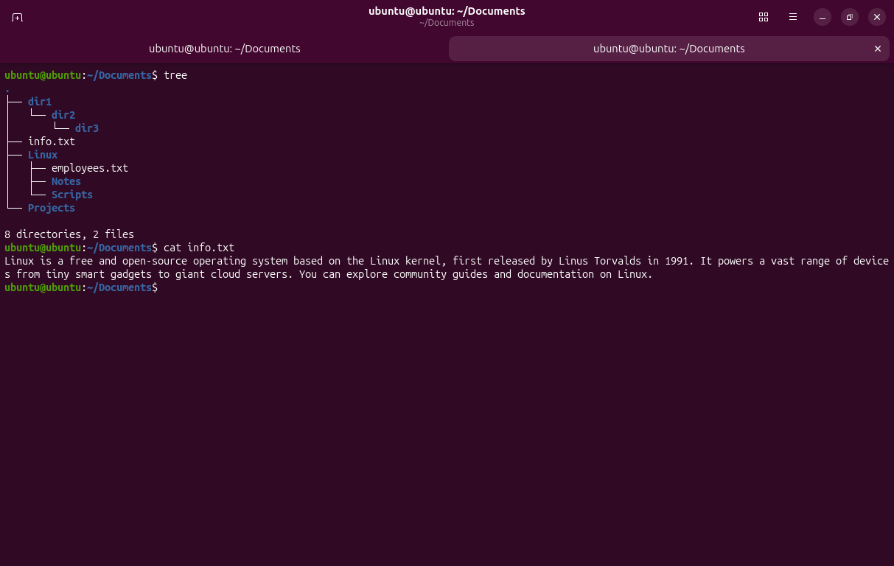
Q13.
Display the contents of two files:
file1.txt
file2.txt
using a single command.
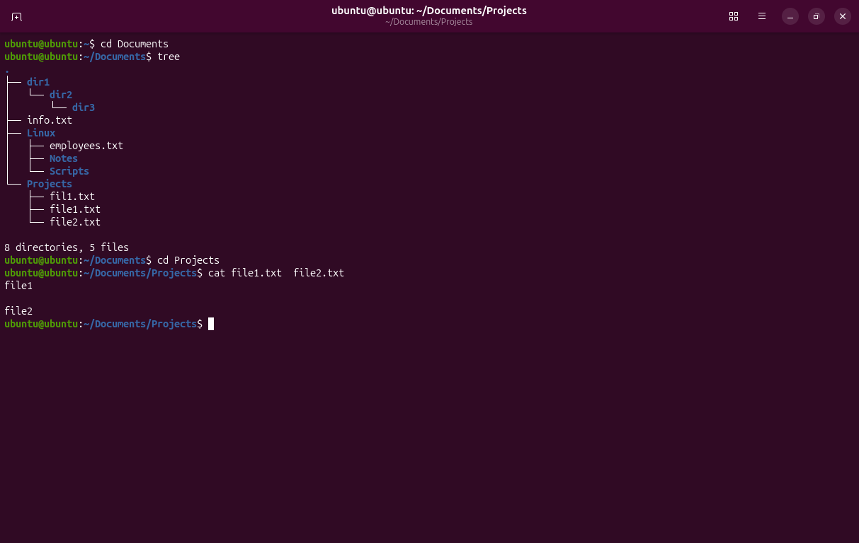
Q14.
Create a file named linux.txt using cat and enter three lines of text.
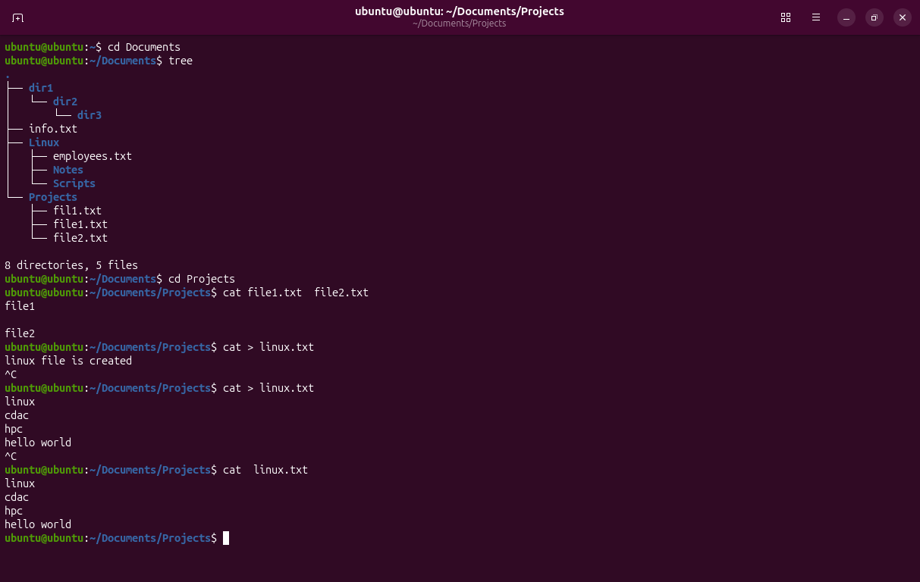
Q15.
Append the text Linux Administration to the end of linux.txt using cat.
Assume employees.txt contains employee details.101 Amit IT Pune 55000
102 Sneha HR Mumbai 48000
103 Rahul Finance Pune 62000
104 Priya IT Bangalore 58000
105 Karan Sales Delhi 45000
106 Neha IT Pune 67000
107 Ankit HR Pune 52000
108 Pooja Finance Mumbai 61000
109 Rohan Sales Pune 49000
110 Meera IT Hyderabad 70000
111 Suresh HR Bangalore 53000
112 Kavita Finance Delhi 65000
113 Vivek IT Pune 60000
114 Anjali Sales Mumbai 47000
115 Mohan IT Delhi 59000
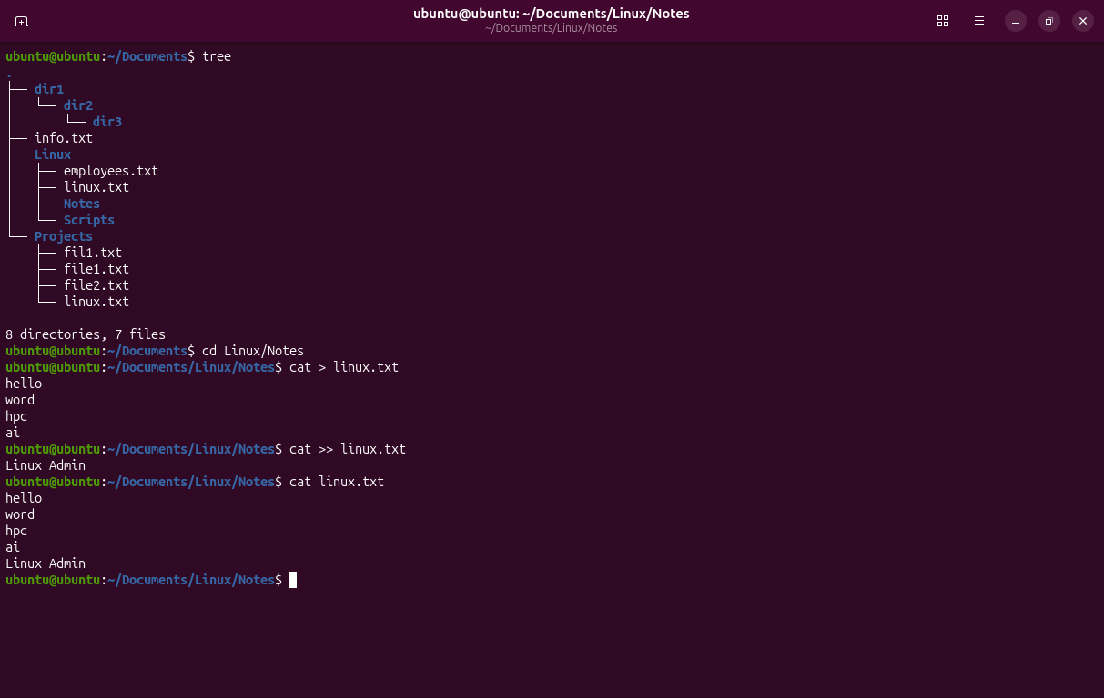
Q16.
Display all employees belonging to the IT department.
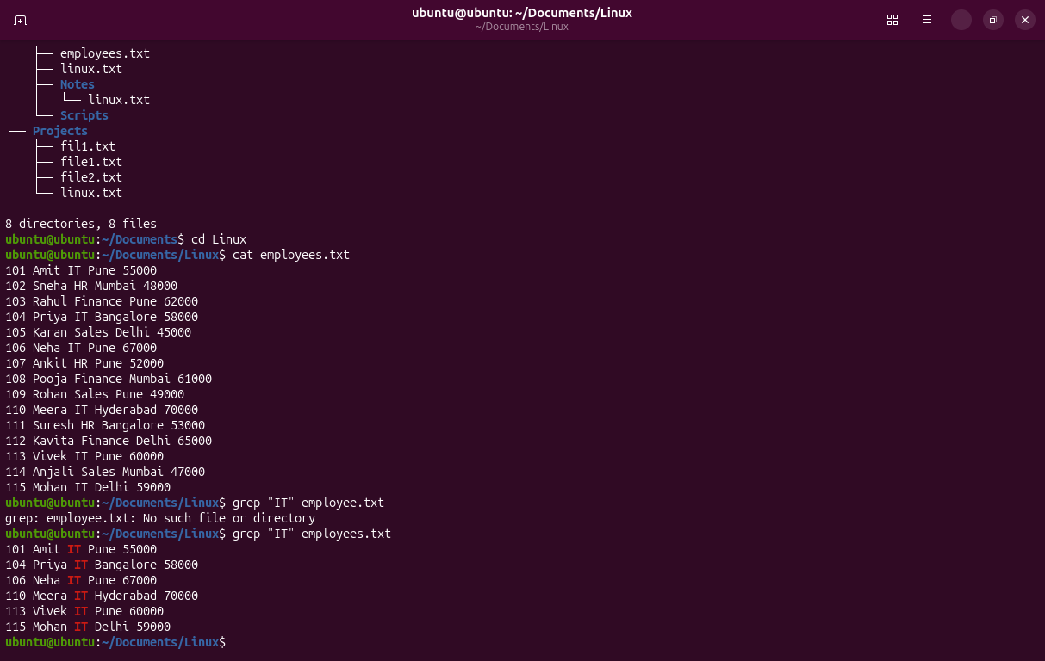
Q17.
Display line numbers along with all matching lines containing Pune.
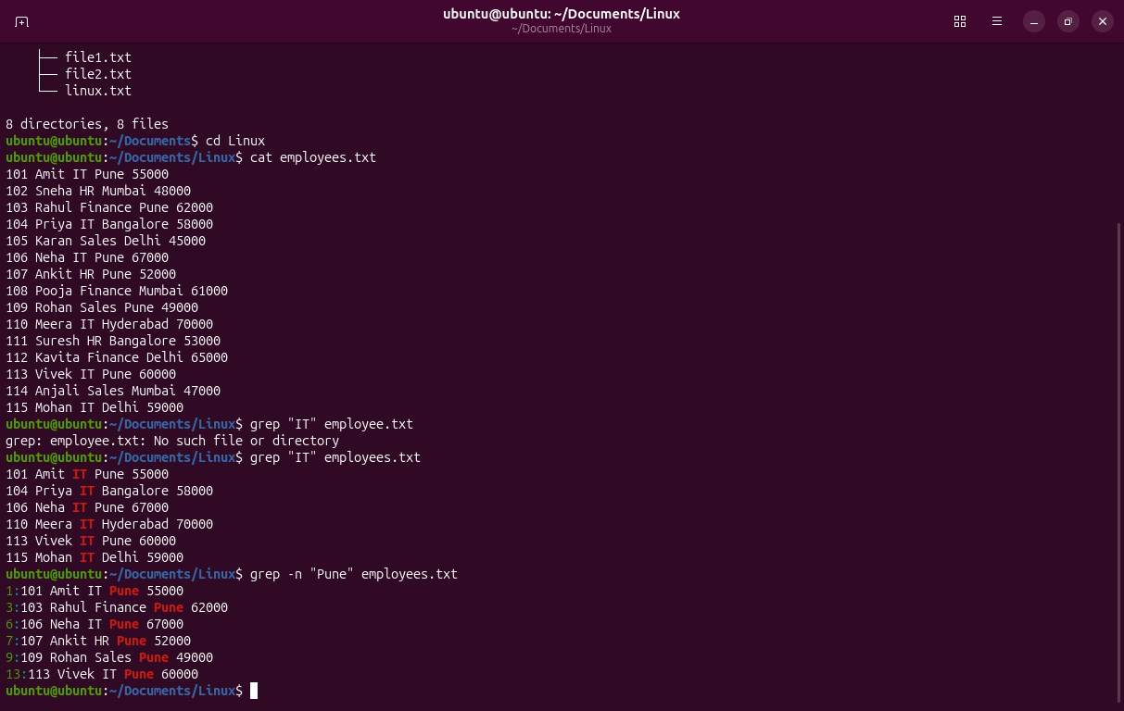
Q18.
Display every line except those containing HR.
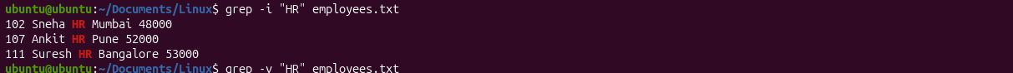
Q19.
Count how many lines contain the word Finance.
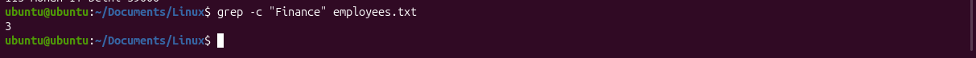
Q20.
Search for the word linux without considering uppercase or lowercase letters.
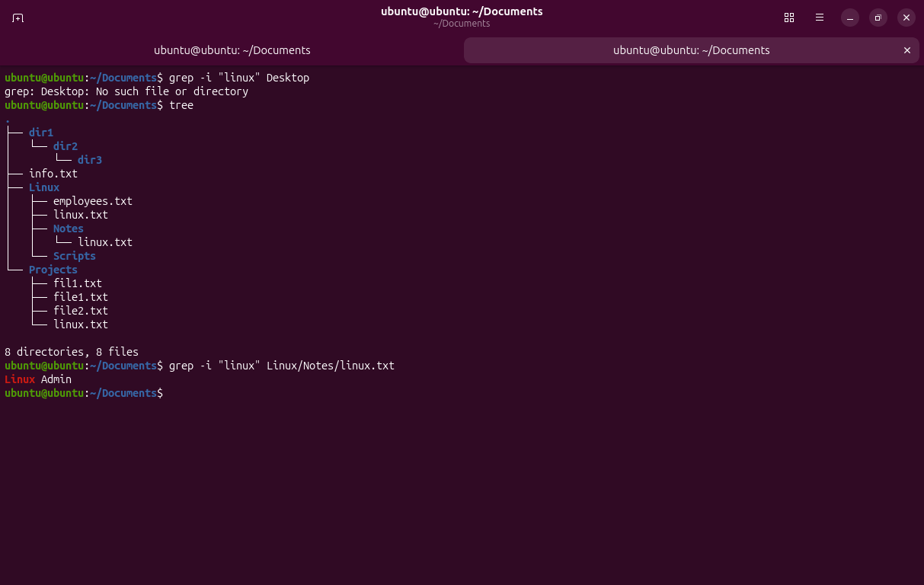
Q21.
Find a file named notes.txt in your home directory.
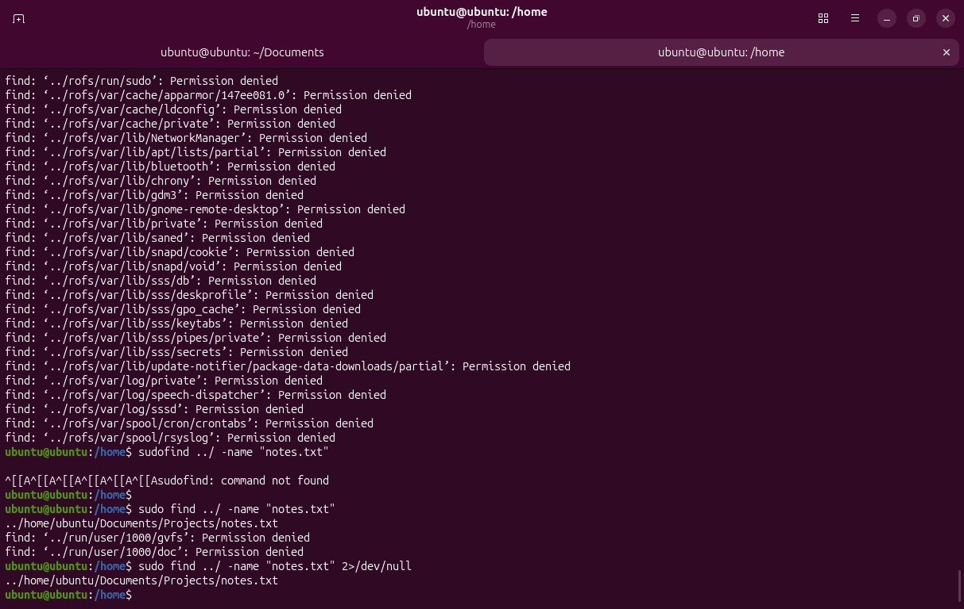
Q22.
Find every directory named Projects.
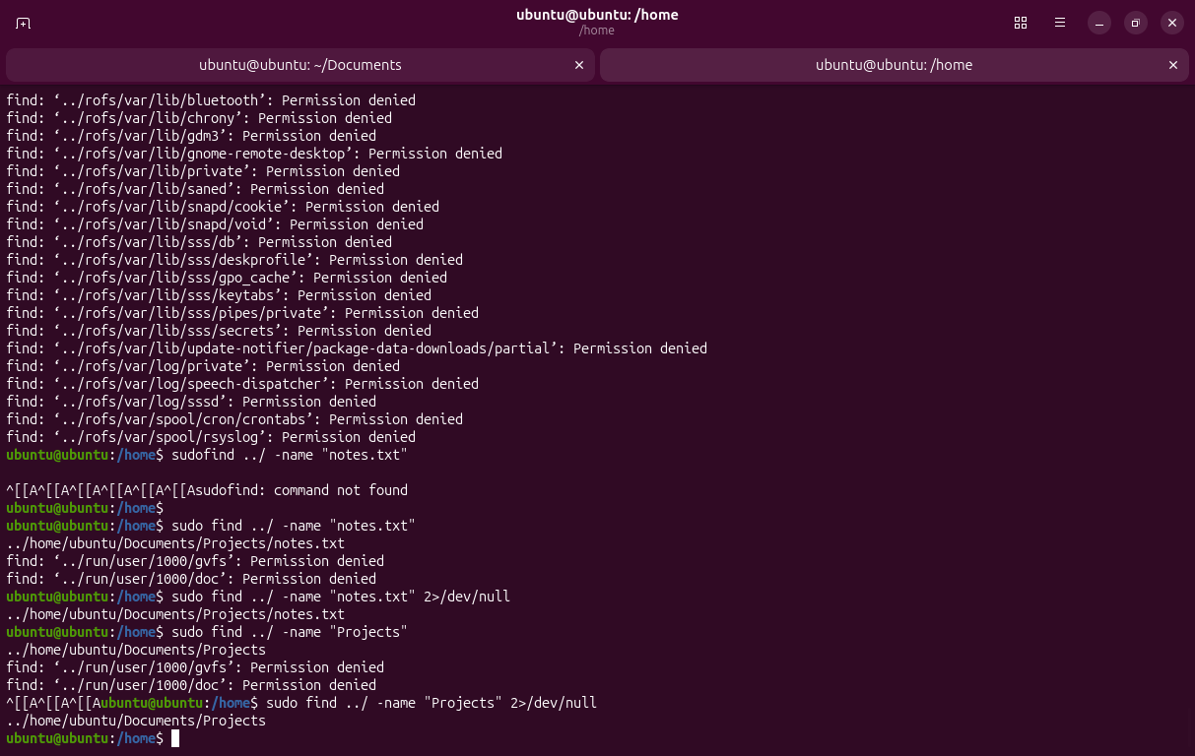
Q23.
Find all files having the .txt extension inside the current directory and its subdirectories.
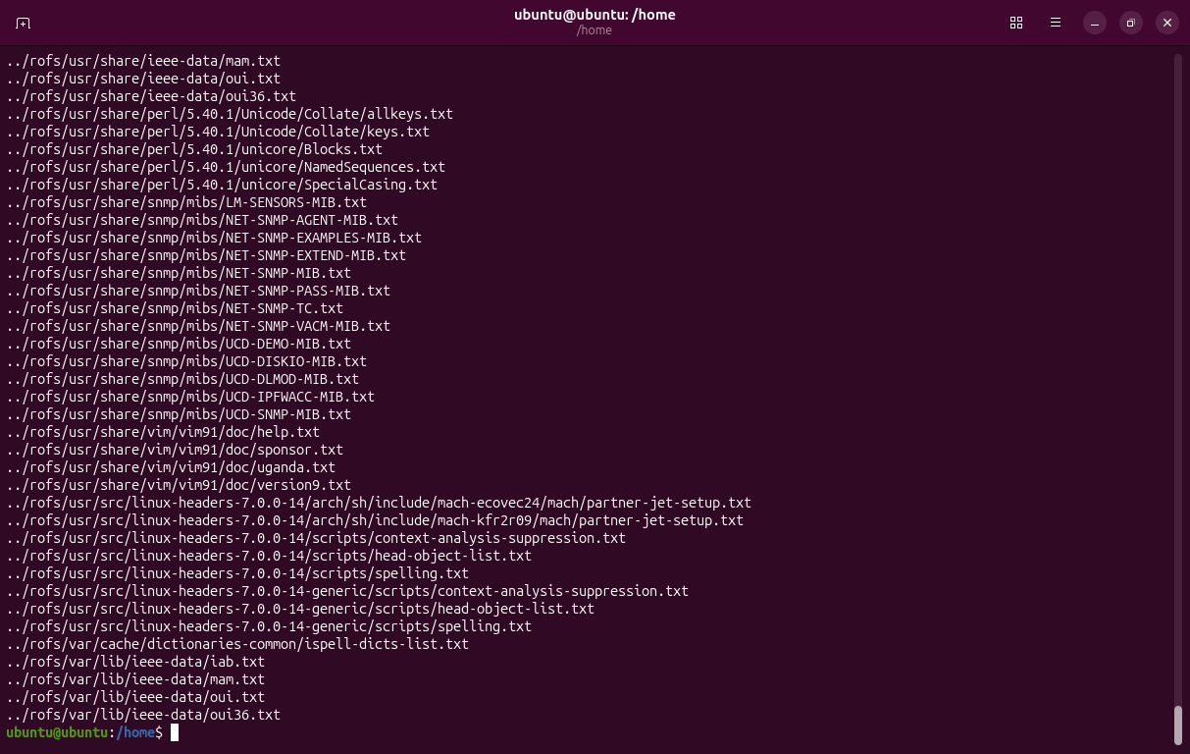
Q24.
Find a file named config.conf starting from the root directory.
(Assume sufficient permissions.)
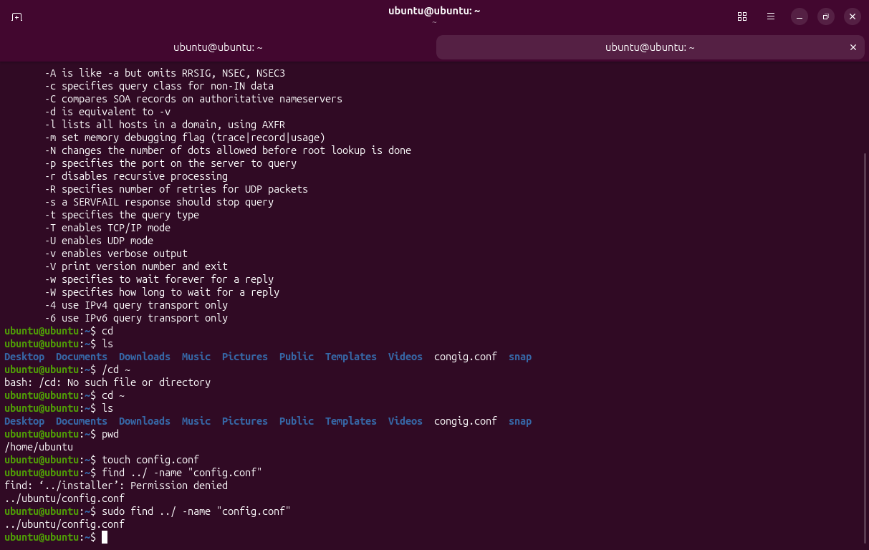
Q25.
Find every file whose name starts with emp.
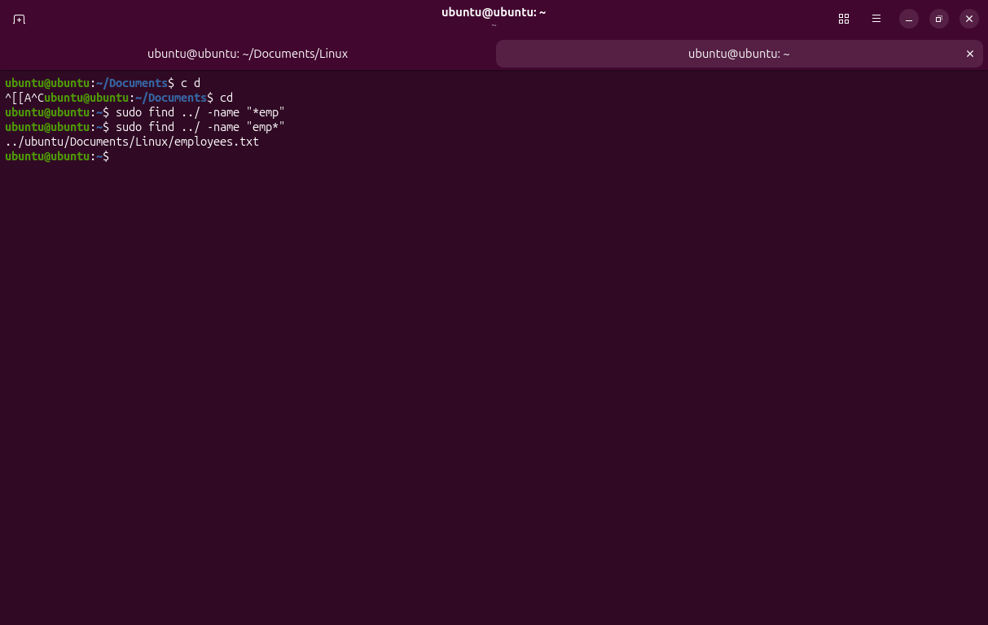
Q26.
Display only the number of lines in employees.txt.
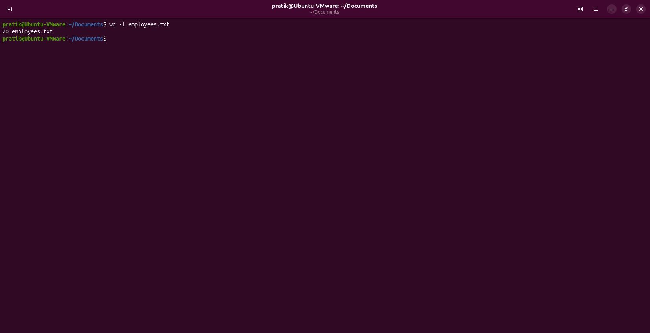

Q27.
Display only the number of words in employees.txt.
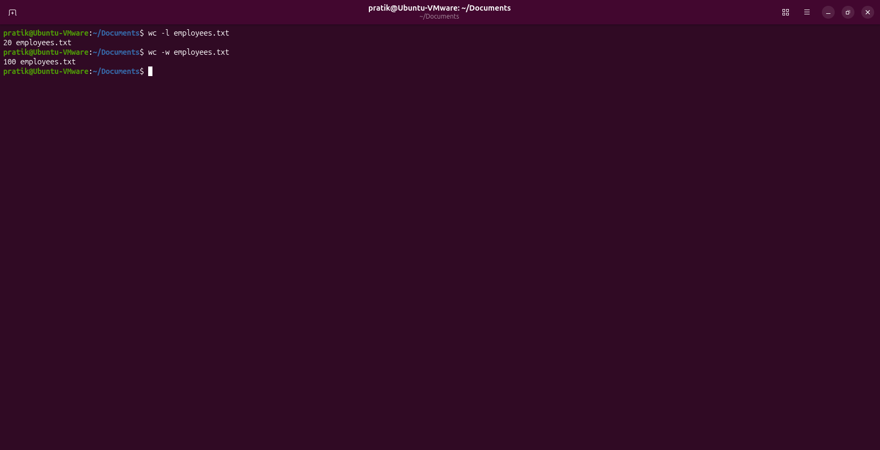
Q28.
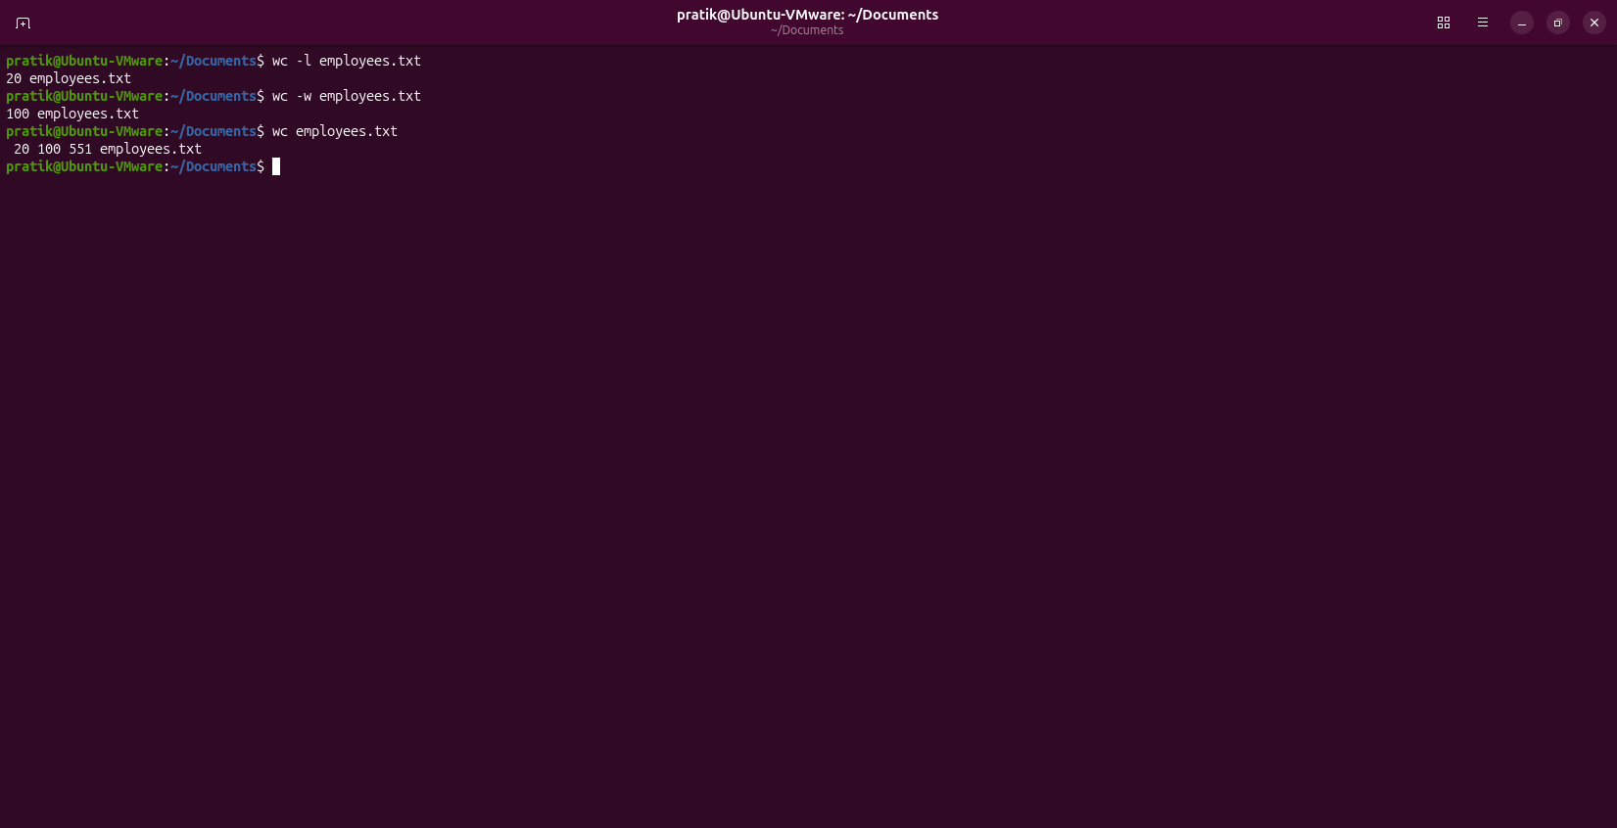
Display the number of lines, words, and characters of employees.txt.
Q29.
Display the contents of employees.txt with line numbers.
Tricky Part: Do not use cat -n.
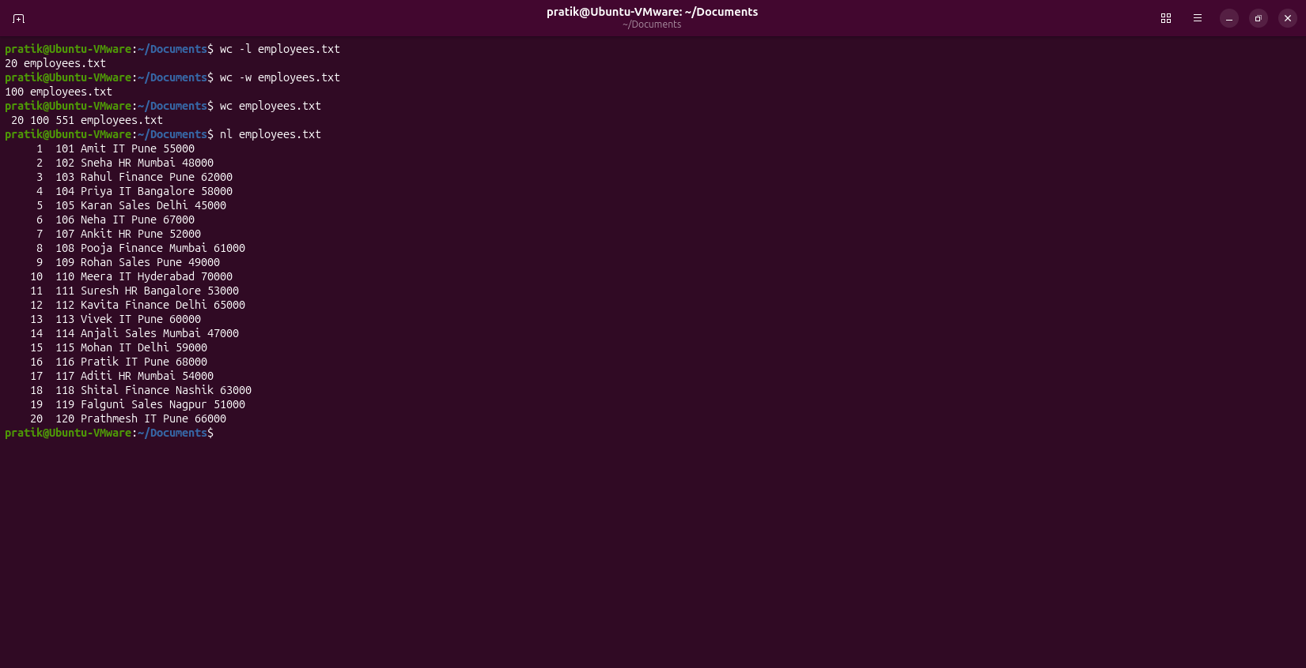
Q30.
Display all environment variables and then find only the variable related to your home directory.Practice
Current directory:
/home/student
Tasks:
2. 3. 4. 1. Display your current directory.
List all files in Documents.
Display the contents of employees.txt.
Search for the word IT.
Find the file notes.txt, display its contents, and count the number of lines in it.
Display all environment variables, then navigate to your home directory using an environment
variable instead of typing the path.
Without entering the /etc directory:
1. List its contents.
2. Find the file hosts.
3. Display its contents.
Current directory:
/home/student/Documents/Linux
Without changing the current directory:
1. List the contents of Downloads.
2. Find report.txt inside Downloads.
3. Display its contents.
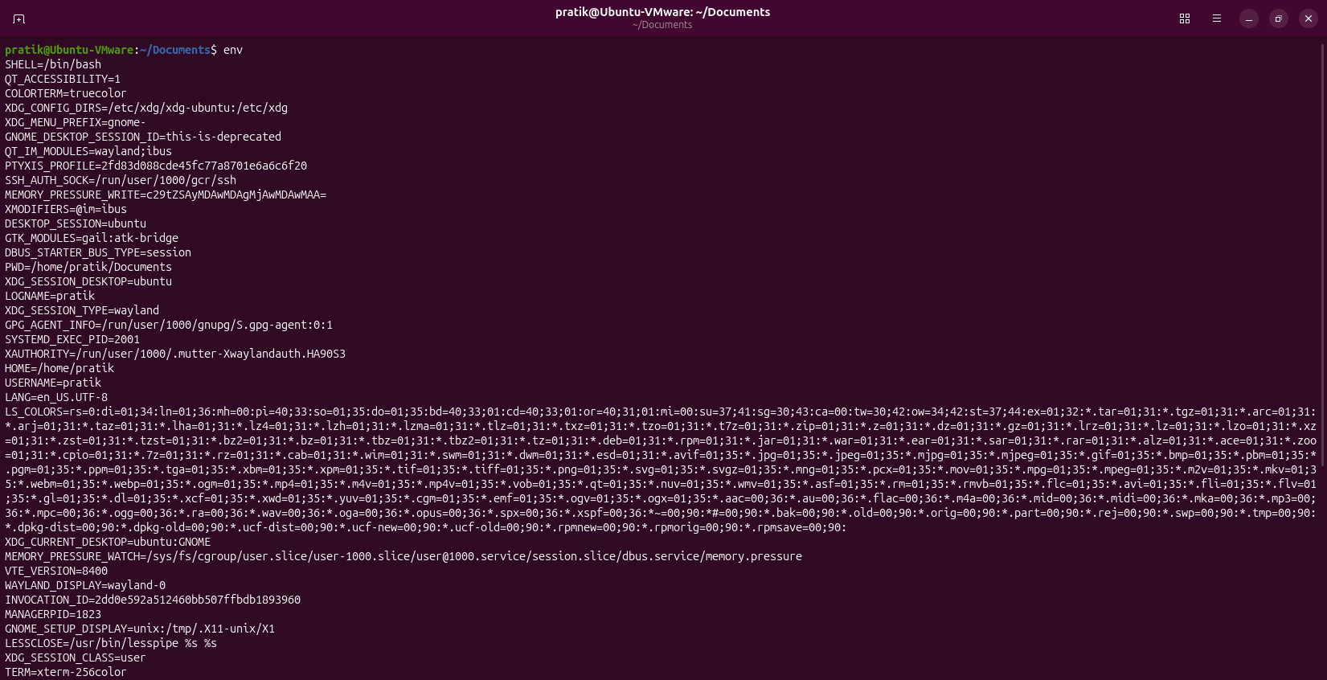

Assignment 5
Q1. Display System Information
Write a shell script that displays:
• "Welcome to Linux"
• Current username
• Current working directory
• Current date and time
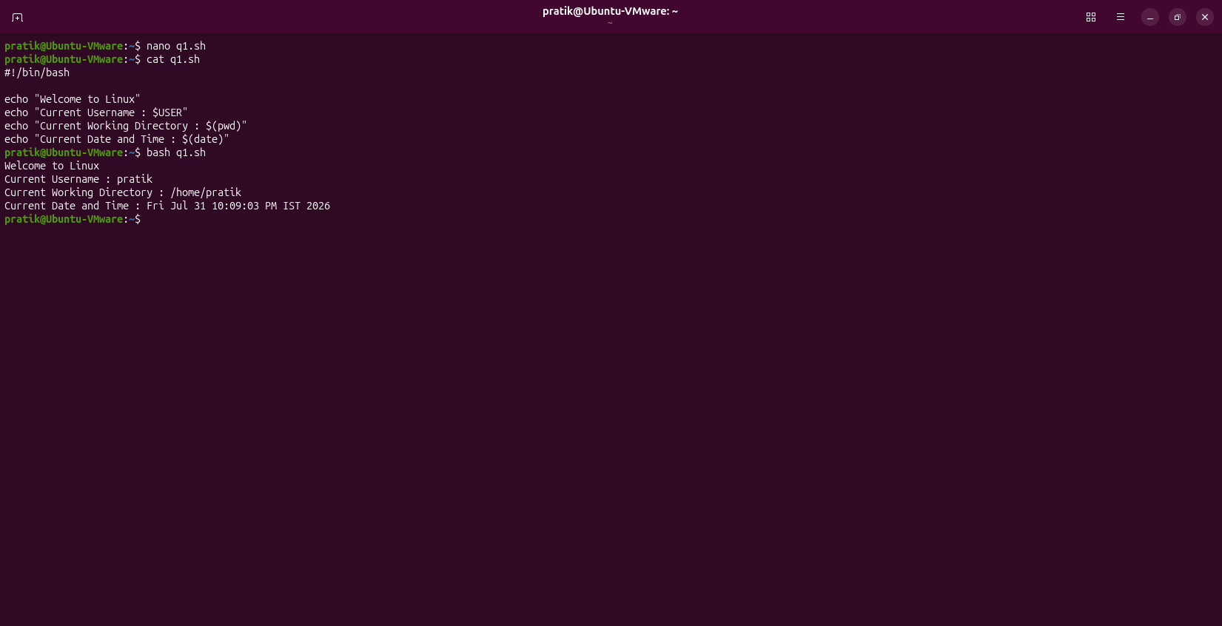
Q2. Display Environment Variables
Write a shell script that displays:
• User's home directory
• Shell name
• Username
• Hostname
Hint: Use environment variables
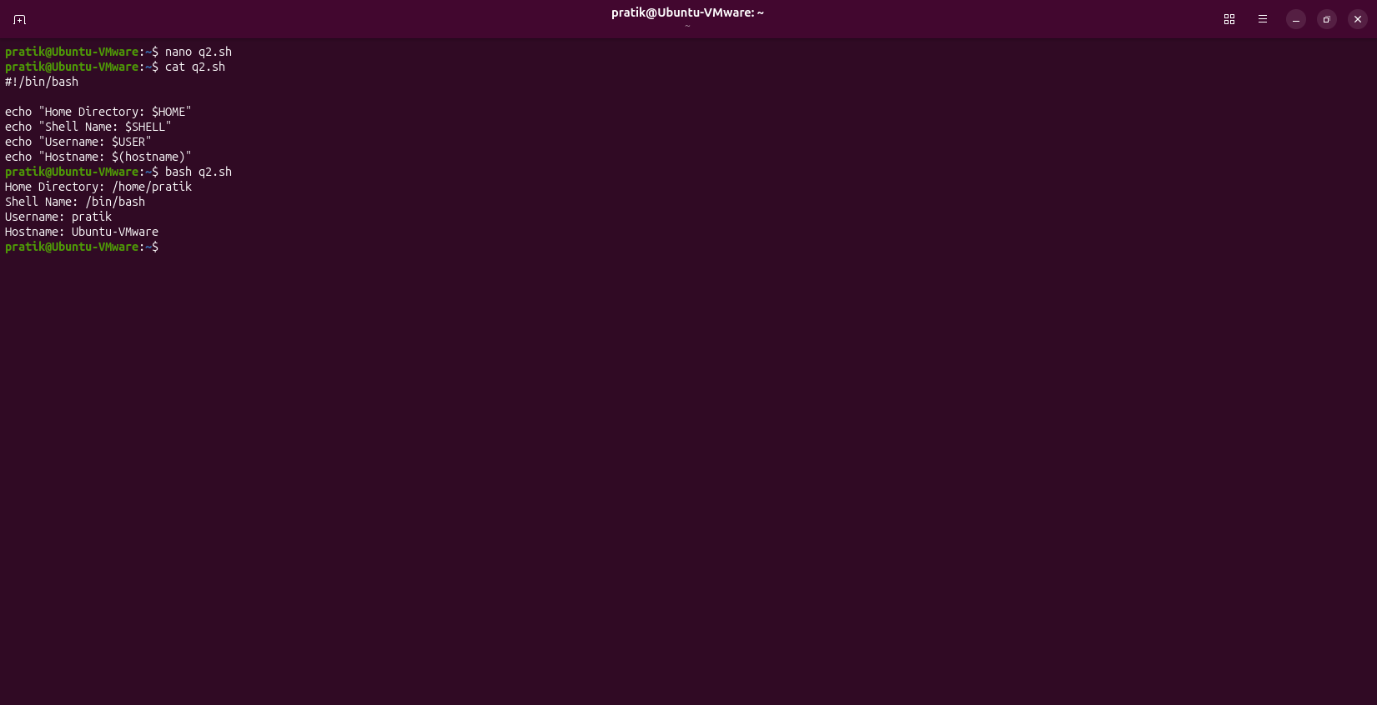

Q3. Read User Information
Write a shell script that asks the user to enter:
• Name
• City
Then display:
Hello <Name>
Welcome from <City>
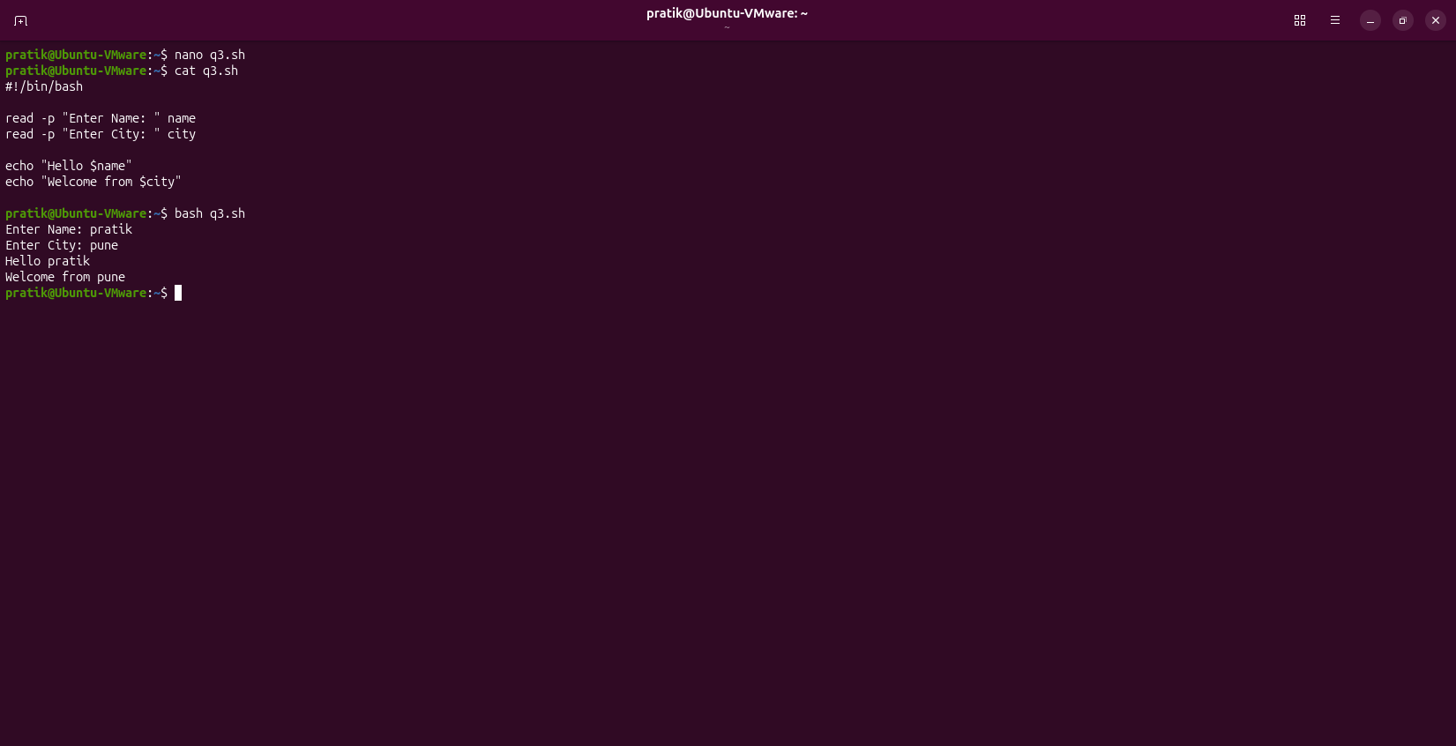

Q4. Display Contents of a File
Write a shell script that asks the user for a filename and displays its contents.
Assume the file exists.
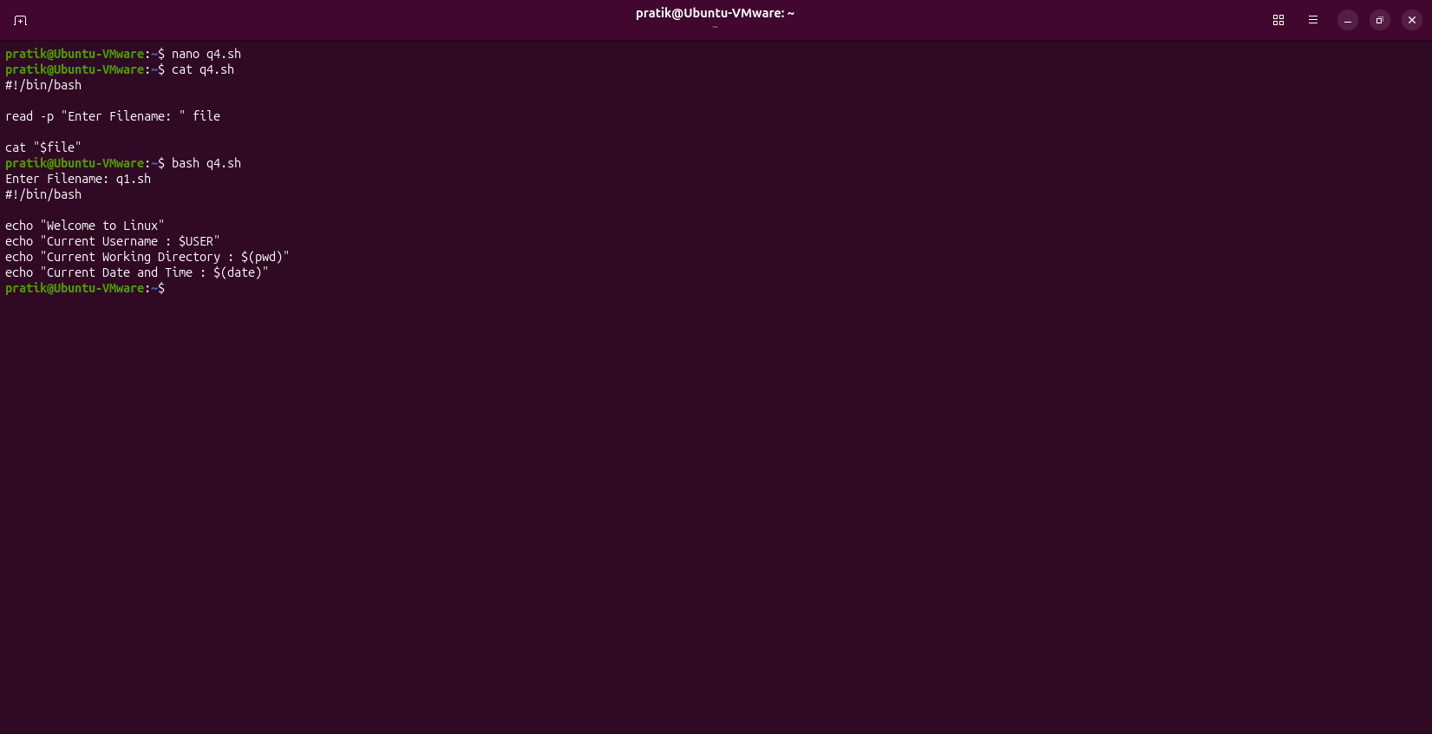

Q5. Count Lines in a File
Write a shell script that accepts a filename from the user and displays only the number of lines in the
file.
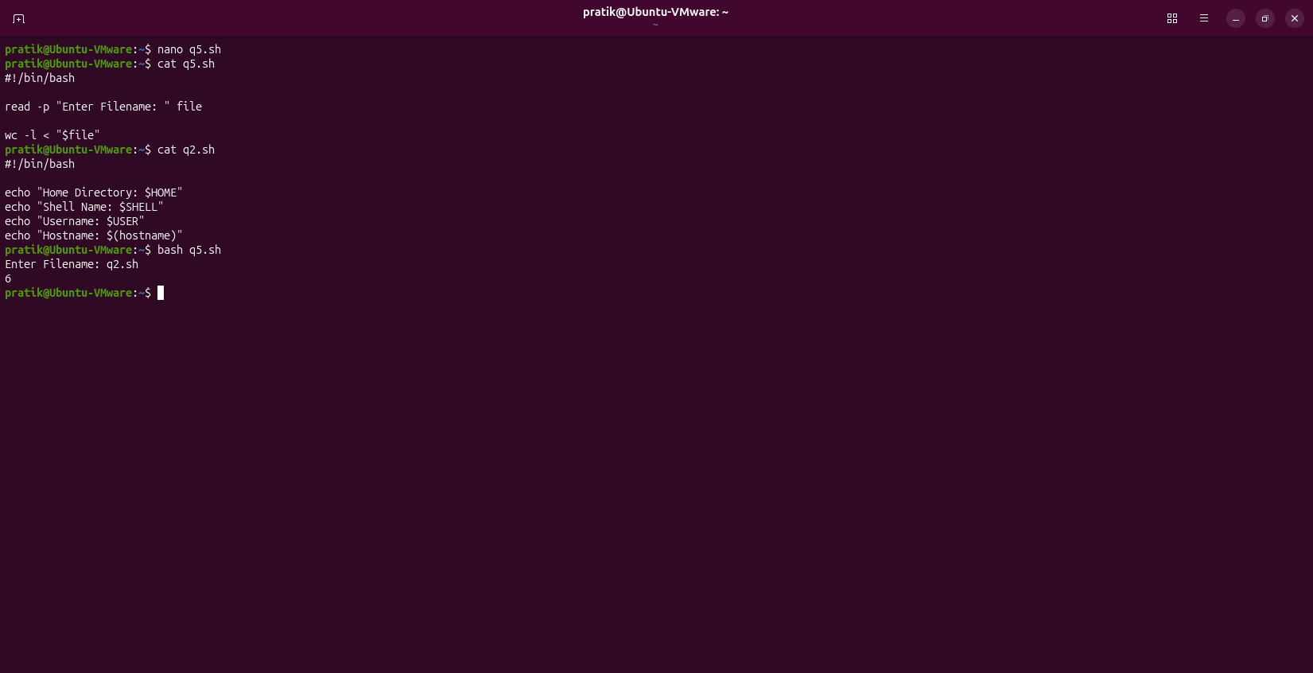

Q6. Search a Word in a File
Write a shell script that:
1. Accepts a filename.
2. Accepts a search word.
3. Displays all matching lines.
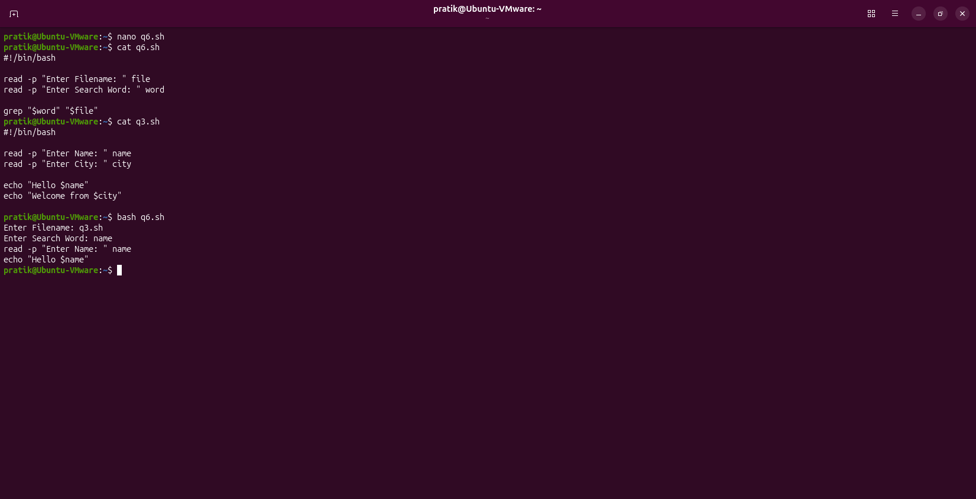
Q7. List Directory Contents
Write a shell script that:
1. Accepts a directory path from the user.
2. Displays all files in that directory in long listing format.
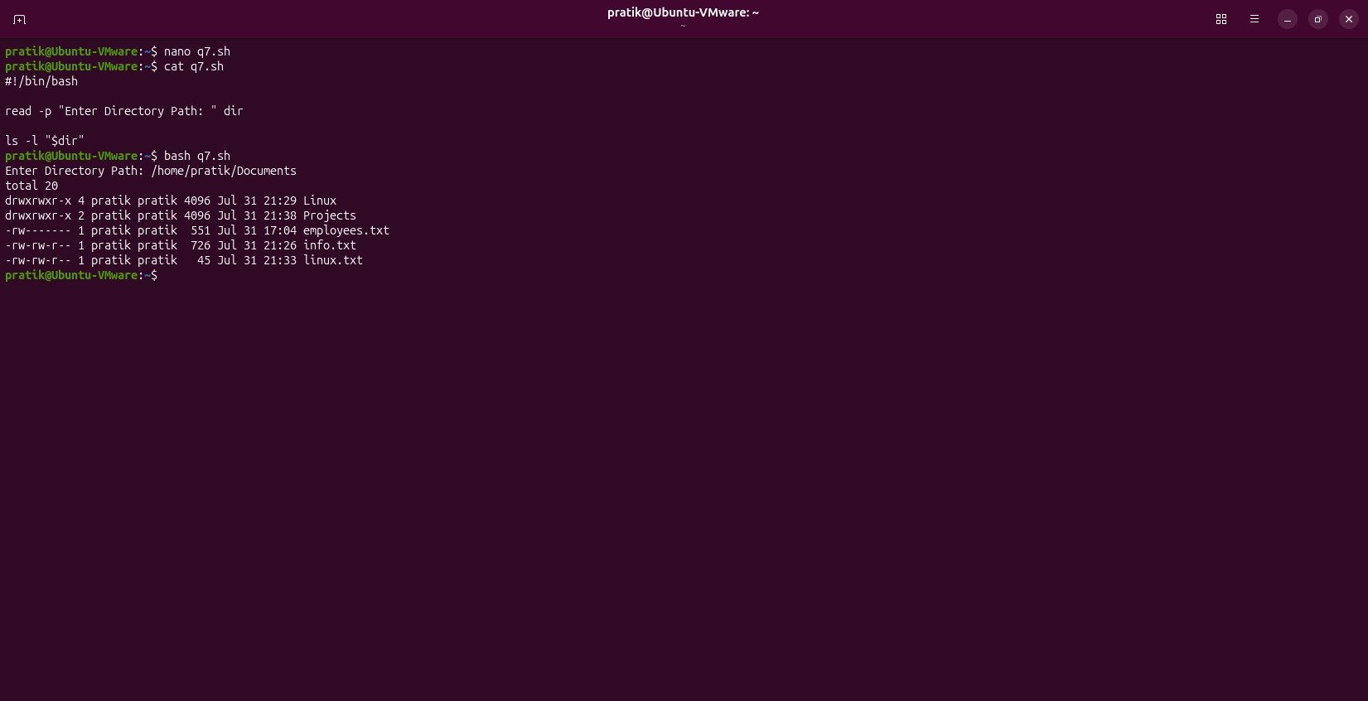
Q8. Display File with Line Numbers
Write a shell script that asks the user for a filename and displays the file with line numbers.
Condition: Do not use cat -n.
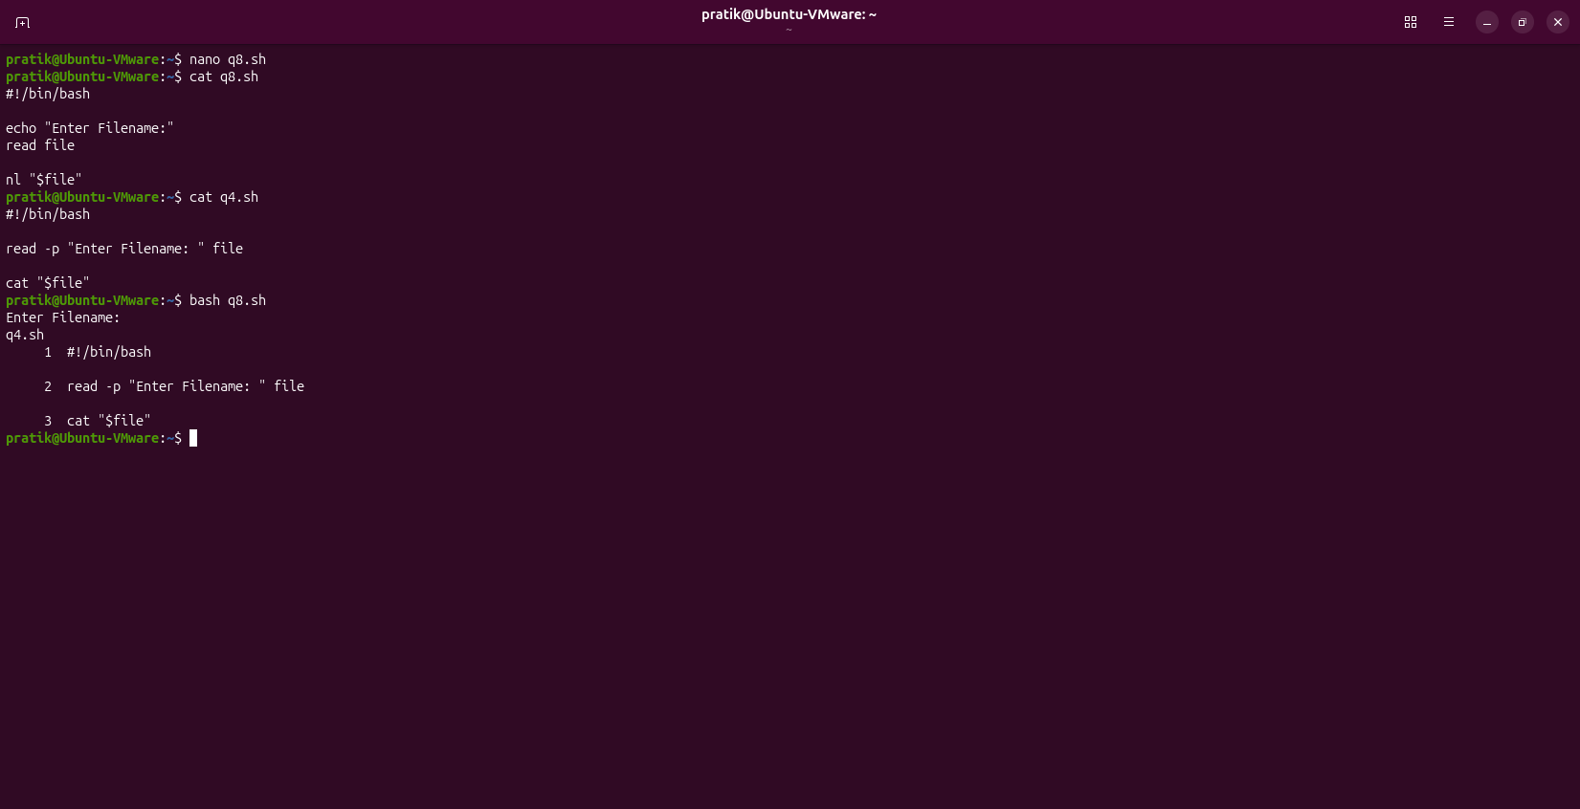

Q9. Display Command Output in a File
Write a shell script that creates a file named systeminfo.txt containing:
• Current date
• Current working directory
• Logged-in username
Display the contents of the file after creating it.
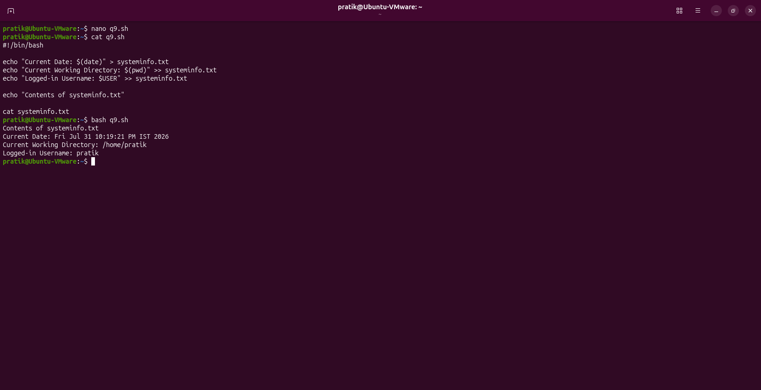

Q10. Multiple Commands in One Script (Tricky)
Write a shell script that performs the following tasks:
1. Displays the current directory.
2. Lists all files, including hidden files.
3. Displays all environment variables.
4. Prints "Script Executed Successfully" at the end.
